**Advanced Web Application Development (CS 421/621)**

**Project Report: Polad Yunisov and Jenna Taer**

***Introduction:***

We will develop an online website to promote our new video games. The website will help in reaching a huge number of audiences, which in turn will increase our sales and profit.

Users of the website will be able to sign up/ log in to our website. They will not be able to access the online store without a log in. In addition, users will be able to add video games to their cart and checkout.

The website will have a user-friendly design.

***Technologies:***

Front-end: An html and a css file were made named “page.html” and “page.css” to access the main page to the store. In this page, the user will be able to add video game to the cart for checkout. This was made possible through the “app.js” file, where the cart system will work through this code. When you add a product to the cart, it will calculate the total price and keep track of the cart. You can also either clear all the cart or remove one item. The price will adjust depending on what is in the cart.

Back-end: A “main.py” and an “__init__.py” files were created to make the flask, werkzeug.security, and SQLAlchemy work as part of the back-end. These files will help the user sign in and sign up to our website. Also, other html files were created including “login.html,” “signup.html,” “and base.html” to make the system work effortlessly.

After the user creates their account, their information will be saved on a file called “db.sqlite.” We can go back and review all those that have logged in and sign up with our services.

***Results:***

This screenshot is when you first enter the website:

You sign up with your email, name, and password:

Then, you must log in to enter the website:

After you log in, it will take you to a welcome page that only shows up to authorized users. You can log out, go to the home page, or visit the store page:

(Welcome Page)

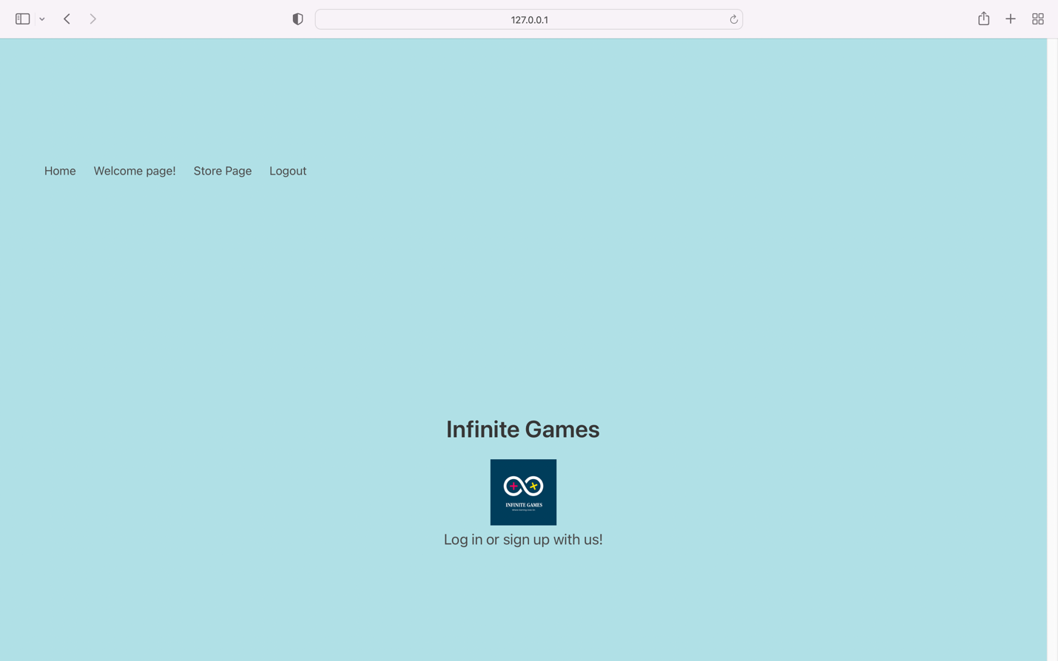(Home Page)

This is the contact us page:

This is the help page:

Now, we will show how the cart system works through screenshots. This is how it looks like empty:

Then, if we remove one game the price will be deducted from the total:

Here is a screenshot of the file called “db.sqlite.” It keeps up with the users signed up.

***Discussions:***

The biggest challenge we faced was putting all the project together. For example, we would code the log in and sign-up pages, but it was difficult to link everything together with the home page. This was also the case for the cart system and the video game website; putting it together was a bit difficult.

Another challenge was using two computers to finish the project. We uploaded the project to github so we can easily share our part of the project when we were done, however, my laptop kept messing up the images and they wouldn’t show up on my end. My partner would fix them but when I push my changes to github it would ruin the pictures again. This kind of slowed things down for us.

***References:***

[***https://flask-login.readthedocs.io/en/latest/***](https://flask-login.readthedocs.io/en/latest/)

[***https://flask.palletsprojects.com/en/2.1.x/blueprints***](https://flask.palletsprojects.com/en/2.1.x/blueprints)

[***https://werkzeug.palletsprojects.com/en/1.0.x/utils/***](https://werkzeug.palletsprojects.com/en/1.0.x/utils/)

[***https://bulma.dev/classes/hero/hero.is-fullheight***](https://bulma.dev/classes/hero/hero.is-fullheight)

[***https://bulma.io/***](https://bulma.io/)